Brian Hartford

Assignment 1 Linux Administration

Install Guides

Today we are going to learn how to install some Linux server distros using only the command line. For convenience’s sake, we are going to install these OS’s on virtual machines. First we will install CentOS and then Ubuntu Server, to test them we will transfer a file between the two.

**CentOS 7**   
  
First we are going to install CentOS, to do this visit the following link:  
<https://www.centos.org/download/>  
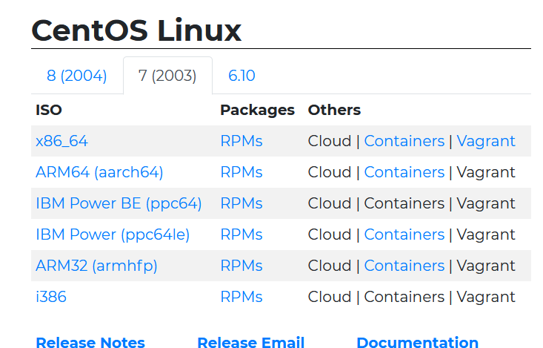  
We will be installing CentOS 7 so select that tab, then select the x86_64 iso image download link.

This will take you to a list of mirrors to download the iso image from, we will be using the DVD image pictured below.

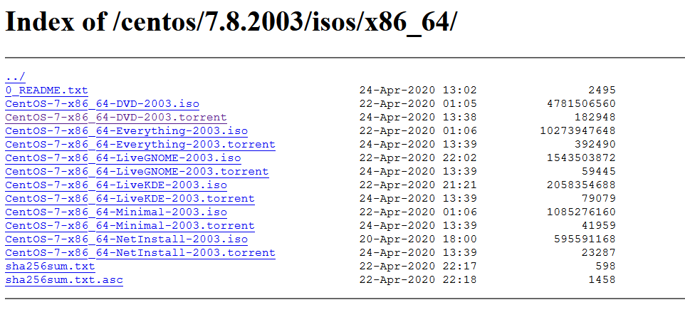

As soons as we boot up the disc image you will be greeted by this screen. We will be installing this without the GUI so instead of pressing enter to “Install CentOS 7” we will be pressing the Tab key.

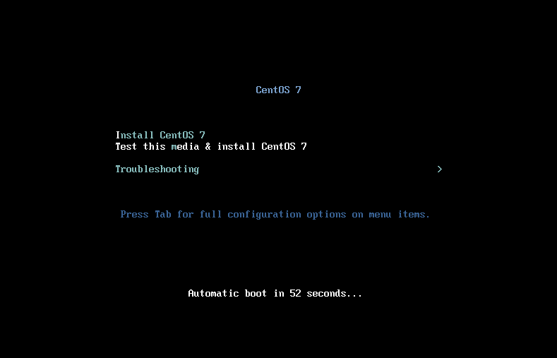

Pressing tab will bring up a command at the bottom of the screen, you will need to add the word “text” to the end of this command and press enter. This will tell the installer that you want to install via command line.

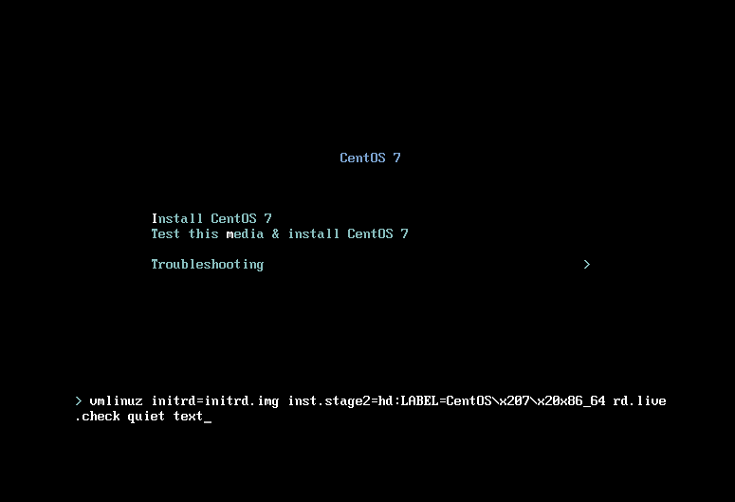

You will then be brought to the text installer menu which looks like this.

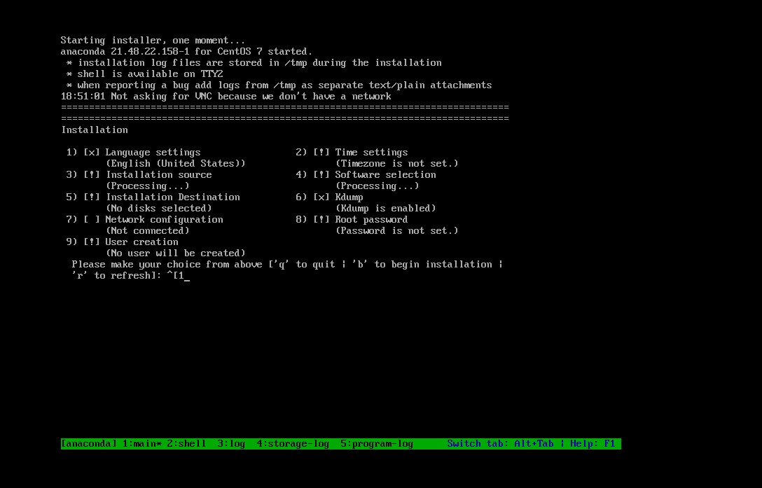

You will need to go through each category that has an exclamation point in the box to resolve issues before proceeding with your install, you can do this by entering the corresponding number on the command line, pressing enter and following the instructions available to navigate the menu.

You will need to select the DVD as the installation source, as pictured below.

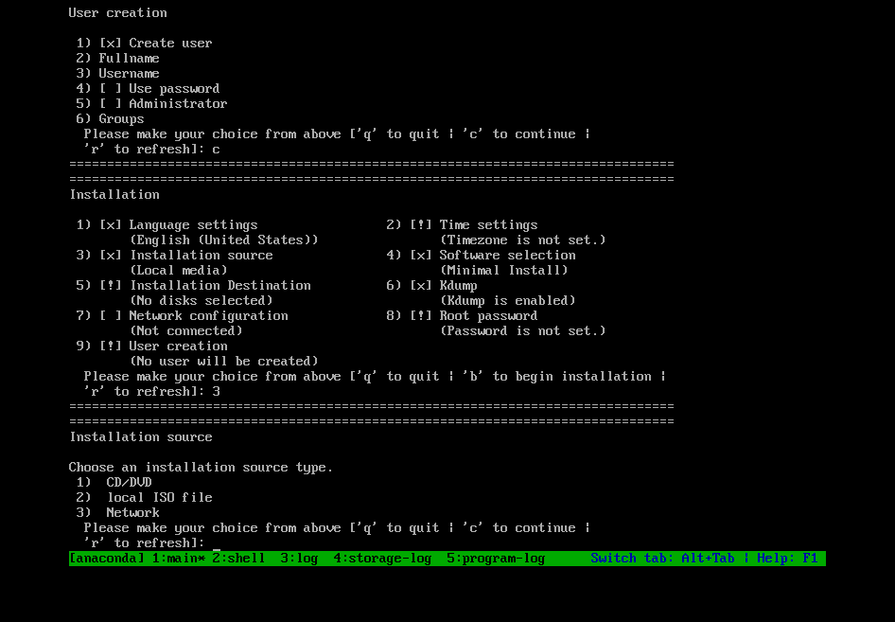

One of the most important selections you will need to make is the type of server software you would like to install. I opted to make mine a file and print server ( we will not be selecting the minimal install)

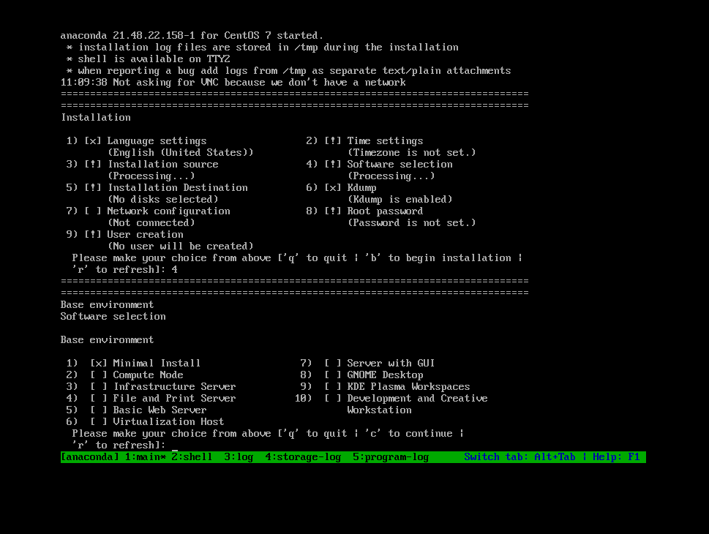

Now we will need to select our installation destination, this will vary depending on what installation medium is used. In this case we are using a virtual machine so we have created a virtual disk to install this on, we will elect to use the entire disk for this installation.

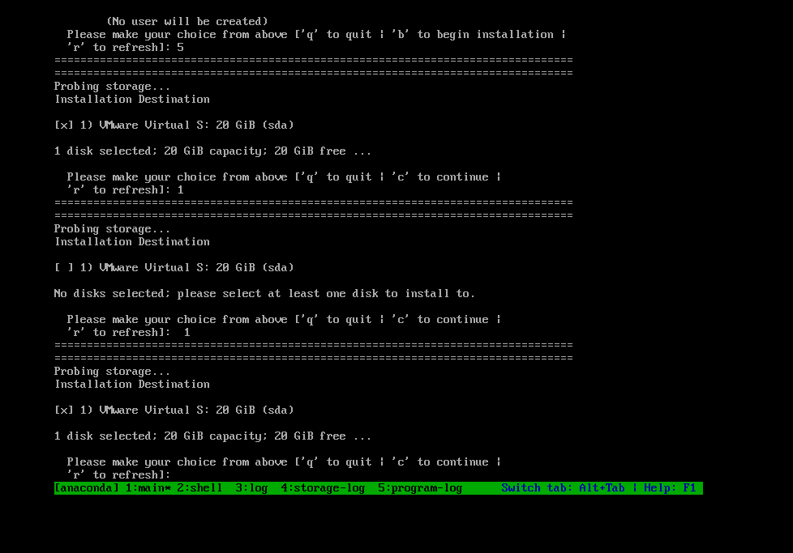

Next you will need to set up your network configuration, which is done in the menu below. You need to choose a host name and also enable DHCP, unless you plan to use a static IP address.

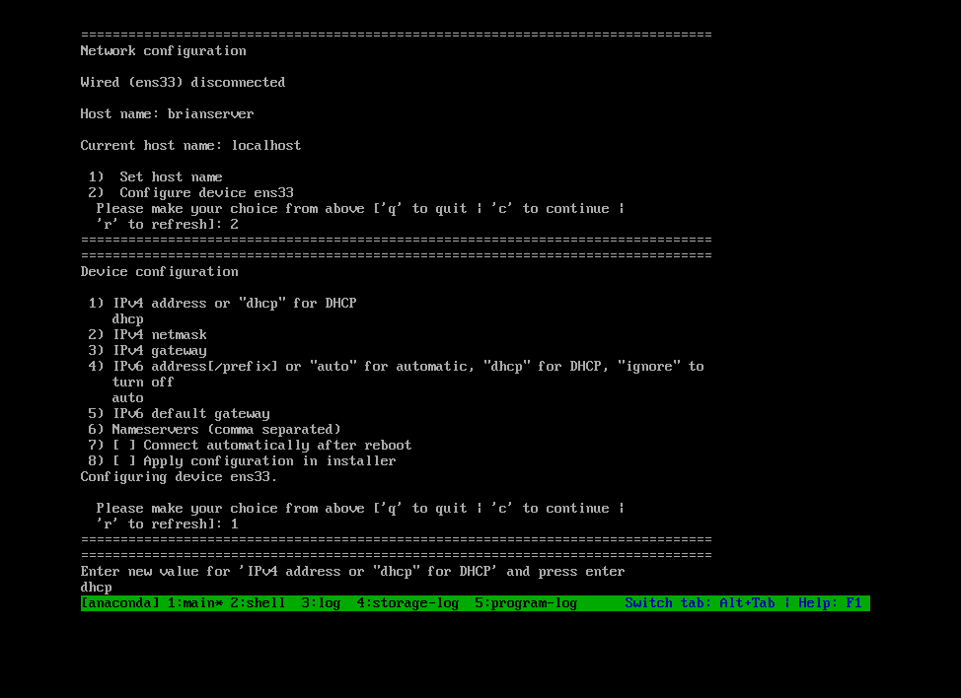

Finally, you need to set up a user and a root password and you are ready to begin the install. The install can be initiated by entering the b on the keyboard when prompted to do so.

Once your install begins your screen will look like this:

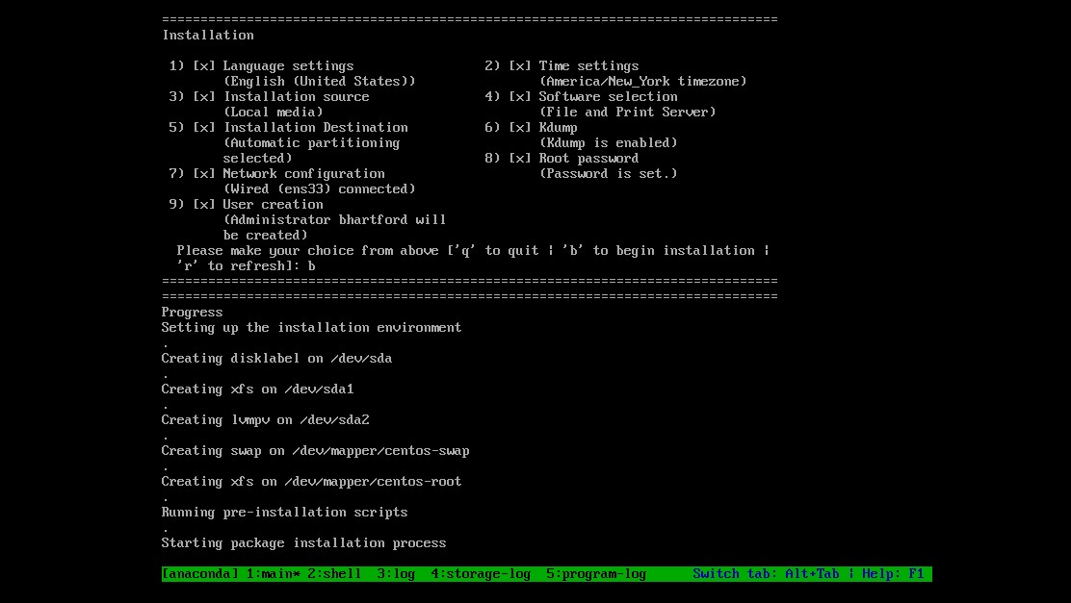

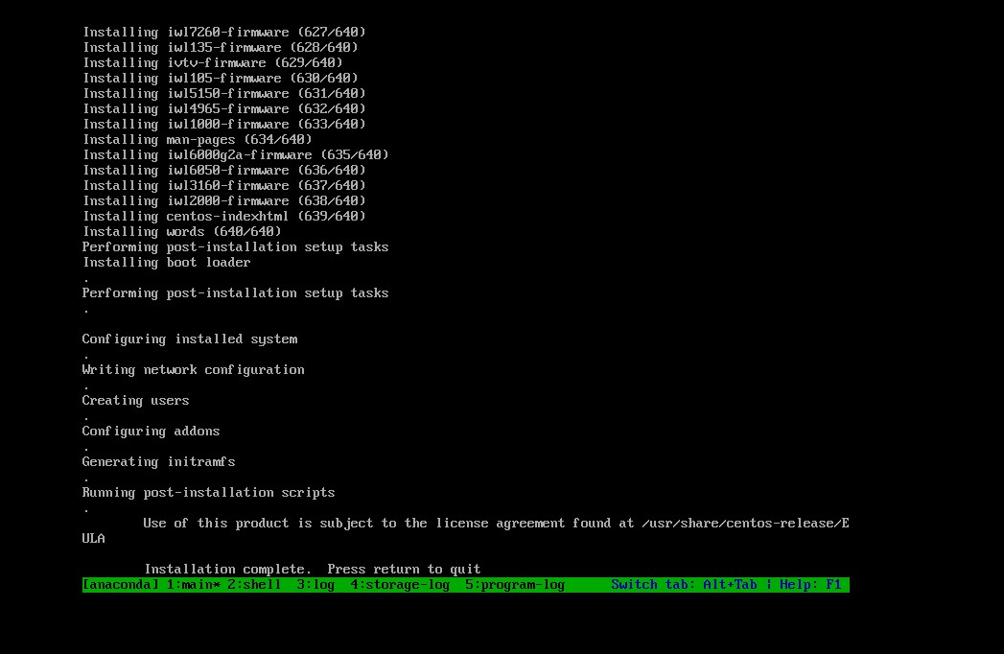

Your installation of CentOS is now complete. You will be greeted with a login screen, which you will use to login with the username and password you created.

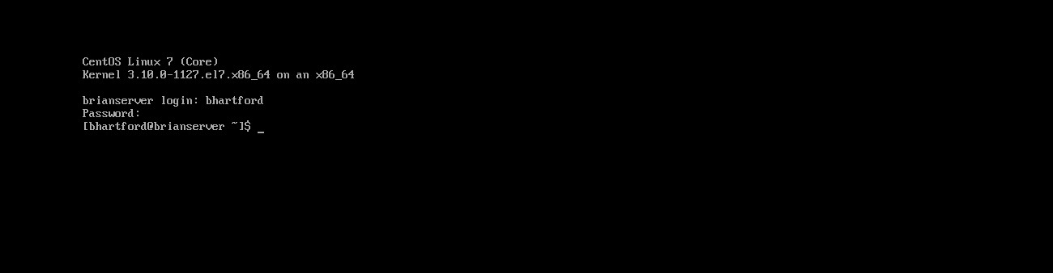

Next it would be a good idea to do a yum update to ensure all of our software packages are up to date. This can be done by typing “ sudo yum update” at the command line.

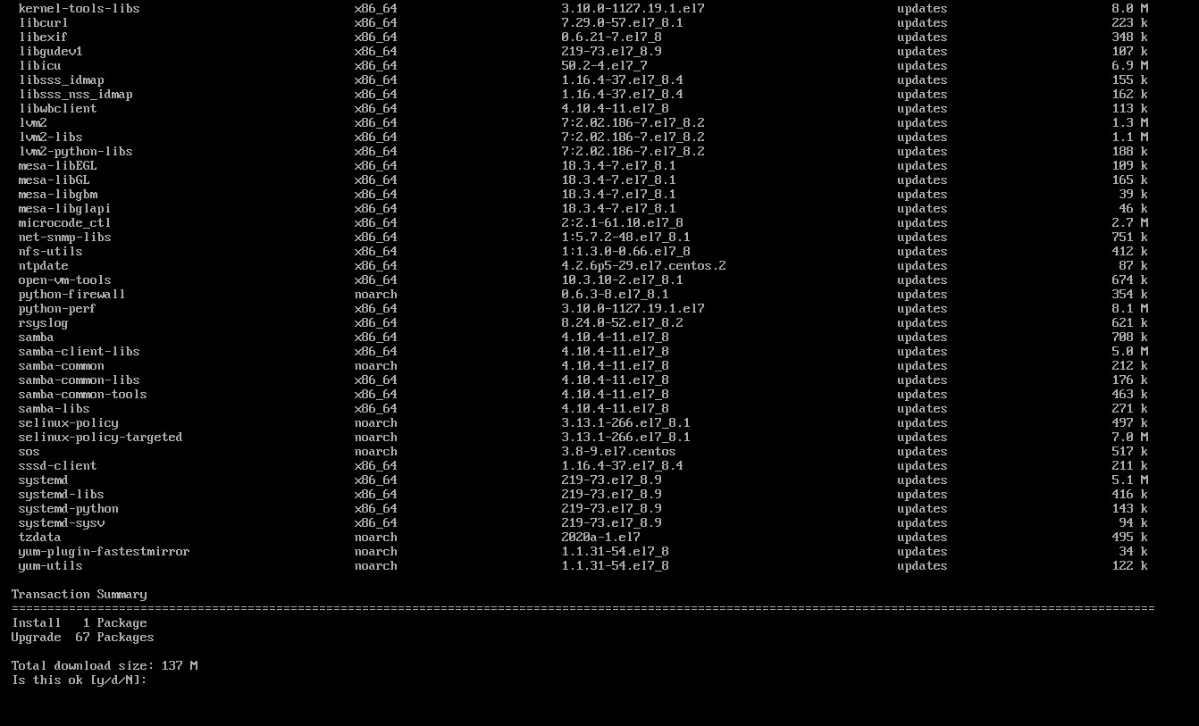

**Installing Ubuntu Server**

In the second part of this guide we will be installing an instance of Ubuntu Server using the command line only.

First we will need to download our disk image to install from, this can be found at the following link:

<https://releases.ubuntu.com/18.04.5/>

You will need to select the server disk image.

WE are going to be creating a virtual machine using Ubuntu server, this guide assumes you already know how to do that. Once we have created our virtual machine it is time to install Ubuntu server.

First we will need to select a network interface, here we have selected the default ethernet interface.

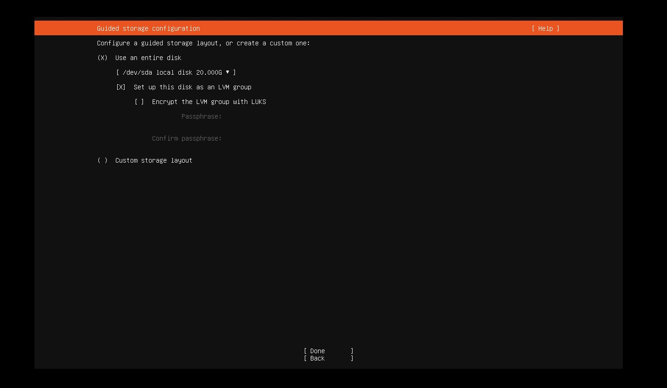

Next we will be selecting a target disk to install this OS to, we will be using the virtual disk we created for the VM.



Below we are going to elect to format our disk to EXT4 filesystem and create a boot partition.

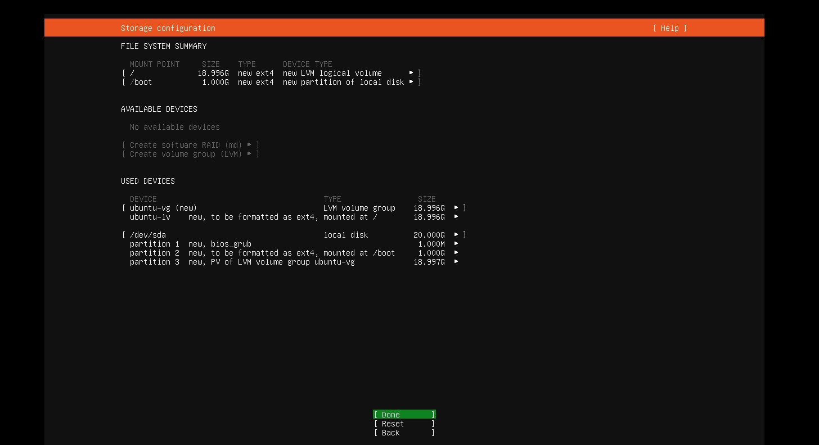

We are then going to begin our install, our screen will look like this below:

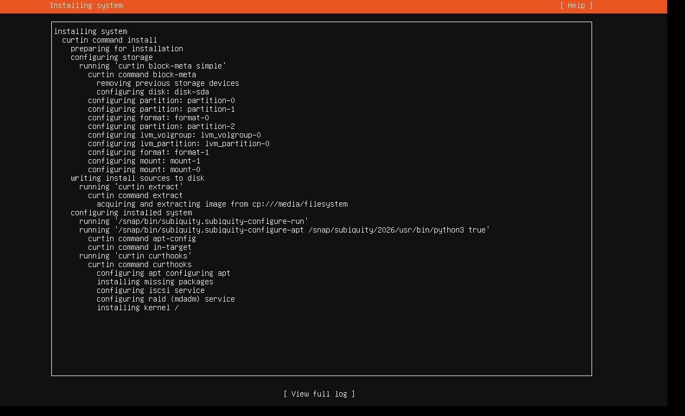

Once this is finished we will be greeted with a login prompt, which we can use to login and then start passing commands to the server.

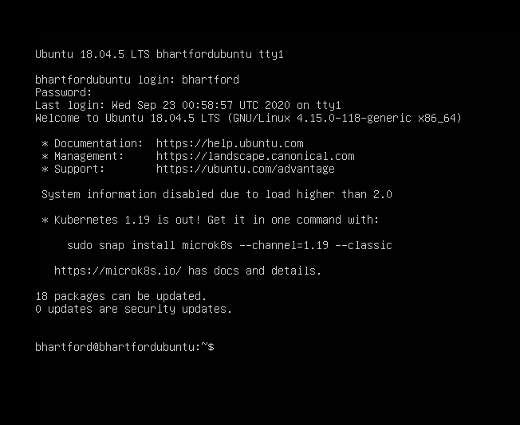

**Transferring files between servers**

Finally we need a way to transfer files between our servers. For now we are going to use SCP to get a test text file from our CentOS server. Below we have successfully copied the file from our remote host (CentOS server) to our Ubuntu server.

